**LAB # 02**

**Task # 01: Implement box plot and histogram for IRIS Data set**

**Solution:**

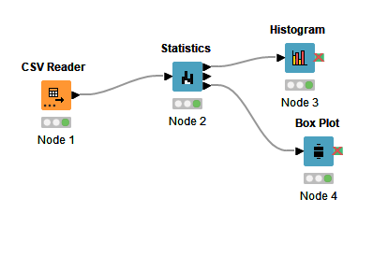

**Output:**

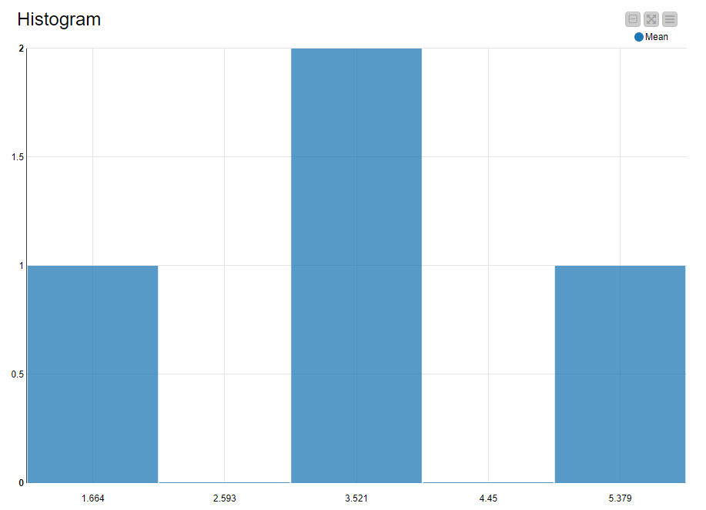 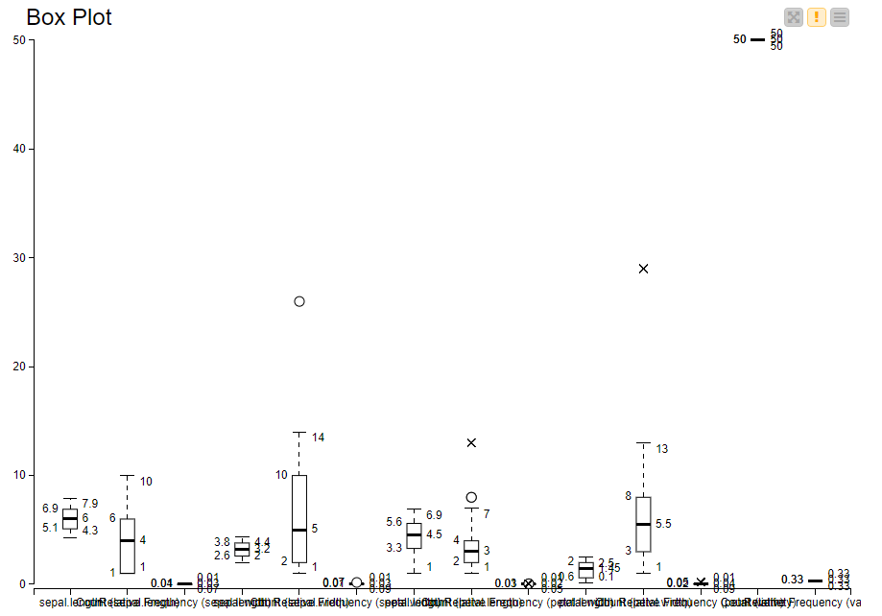

**Task # 02: In a workflow group create an empty workflow “exercise1”**

**a. Read CSV file**

**b. Remove irrelevant columns**

**c. Enter the name and description for all nodes in the workflow**

**d. Performed basic statistics**

**e. Performed the column and row filter and finally write the data to output file.**

**f. Save and execute workflow exercise 1.**

**Solution:**

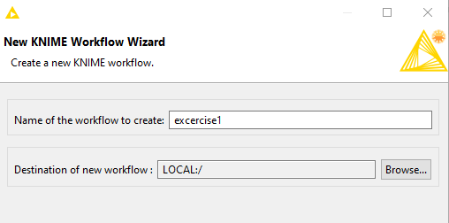

**Read CSV file:**

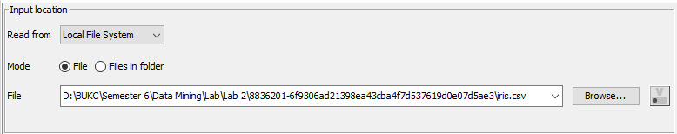

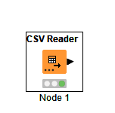

**Remove irrelevant columns:**

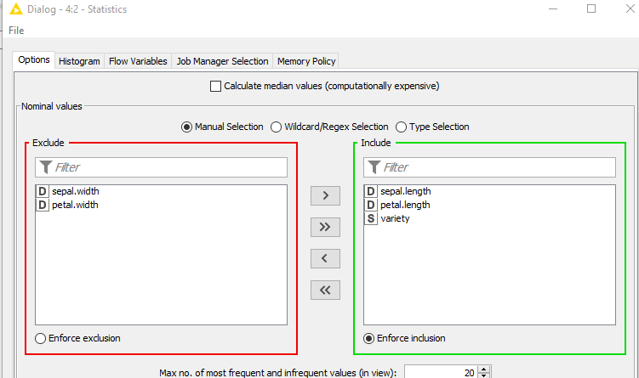

**Enter the name and description for all nodes in the workflow:**

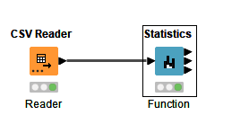

Reader read the file while function remove irrelevant column and rows from csv file and also perform statistics method

**Performed basic statistics:**

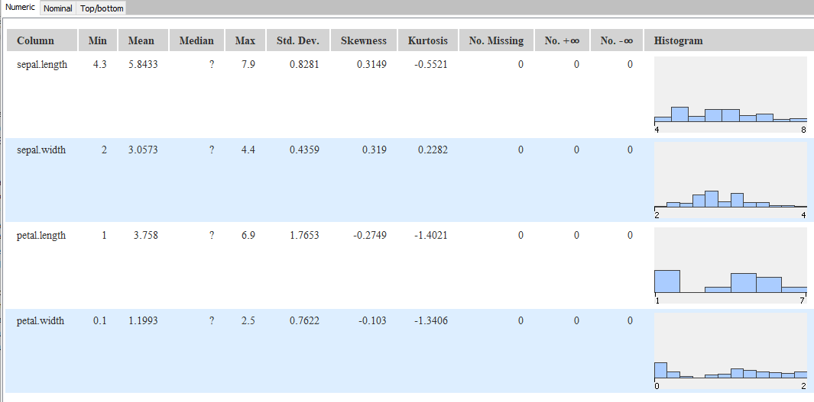

**Performed the column and row filter and finally write the data to output file:**

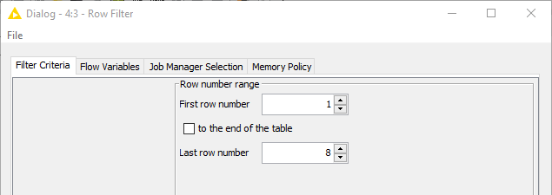

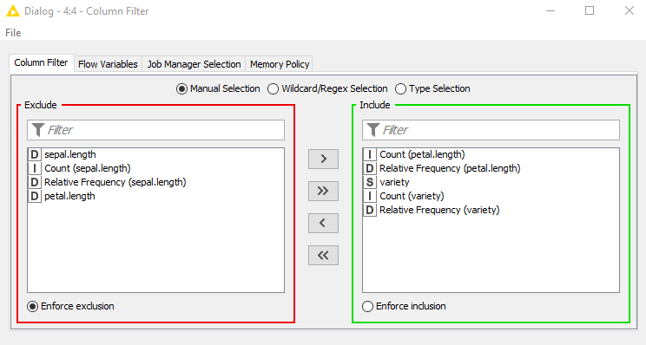

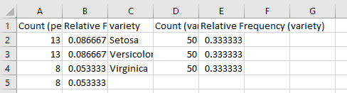 

**Save and execute workflow exercise 1.**

